WELCOME TO
B-30 Box Cup THE 15.th

8-9.OKTOBER 2016
LOCATION: ROSTENHALLEN V/CITY SYD
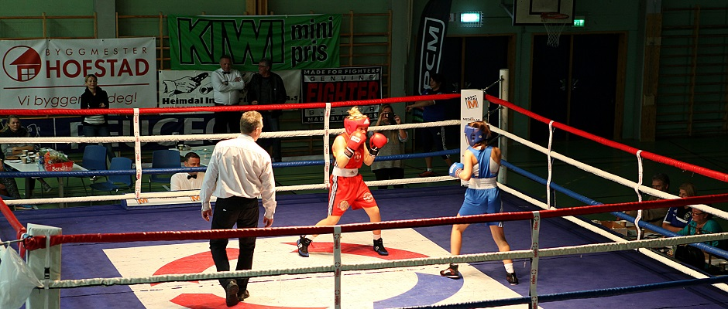

SOME OF OURS SPONSORS:

TRONDHEIM KOMMUNE QUALITY HOTEL PANORAMA TEMPE AUTO AS

NORGES BOKSEFORBUND ATLE REILO BYGGMESTER HOFSTAD AS

www.b-30.no

Location: ROSTENHALLEN v/ CITY SYD adress: Østre Rosten 39 7075 TILLER
15 minutes with bus (bus nr. 46 from Pirbadet/Prinsenkrysset) or 10-12 minutes with taxi from center of Trondheim.

Date: 8.-9.oktober 2016

Weighing: Saturday 08.30 – 10.30 i Rostenhallen, Østre Rosten 39.

Boxing starts at:
Saturday 14.00 *
Sunday 10.00 *

* If there are many boxers we may have to start earlier

Drawing: At weighing Saturday morning

Referees and judges: We kindly ask all clubs participating to bring their referees and judges
Starting fee: 200,- NOK pr. boxer

Classes:

- Diploma, born 2002-2005. (Only technical boxing) Divided by age and number of matches. Boxer must be 11 year.
- Micro-diploma, born 2006-2008. No winner, only show of technical boxing.

Junior born 00-01: | Junior A | 7- matches | 3 x 2 min Men/ 3x2 W
 | Junior B | 0-6 matches | 3 x 2 min Men/ 3x2 W
Youth born 98-99 | Youth A | 16- matches | 3 x 3 min Men/ 4x2 W
 | Youth B | 6-15 matches | 3 x 3 min Men/ 3x2 W
 | Youth C | 0-5 matches | 3 x 2 min Men/ 3x2 W
Elite born 97 and older | Elite A | 16- matches | 3 x 3 min Men/ 4x2 W
 | Elite B | 7-15 matches | 3 x 3 min Men/ 4x2 W
 | Elite C | 0-6 matches | 3 x 2 min Men/ 3x2 W

Women are divided in the same classes as men
If there are more then 4 boxers in a class it will be divided
The organizer will move a boxer up or down, between the classes, if they see this better for the boxing.

Weight categories:
Men: Elite and Youth. 46-49, 52, 56, 60, 64, 69, 75, 81, 91 og +91 kg
Women: Elite and Youth. 45-48, 51, 54, 57, 60, 64, 69, 75, 81 og +81 kg
Junior: Girls and boys. 44-46, 48, 50, 52, 54, 57, 60, 63, 66, 70, 75, 80 og +80 kg
Diploma: Girls and boys. 28, 30, 32, 34, 36, 38, 40, 42, 44, 46, 48, 50, 52, 54, 57, 60, 63, 66, 70, 75, 80 og +80 kg

Prizes:
Cups to best boxer in each class. Medals to all finalists.
Food: It will be possible to buy something light to eat and drink at the sportsarena!

Accommodation:

We encourage all our participants to use our collaborator Quality Hotel Panorama!
A good price & 500m to Rostenhallen and the shoppingcenter City Syd near by!
Free parking at the hotel!

Quality Hotell Panorama
Ivar Lykkes vei 1
7075 Tiller
www.nordicchoicehotels.no
Order before 16. september 2016

Price per room: NOK 680,- inkl. MVA pr night pr single room
NOK 880,- inkl. MVA pr night pr double room with breakfast
+ kr 250,- pr extra bed in a double room with breakfast

Referencenumber 2539 must be used when ordering!

Order directly to the hotel, send e-mail: q.panorama@choice.no
or call this number: 0047 72 90 05 00

Everybody orders and pay their own room.

Send your written entries to:

Bokseklubben av 1930,
Postboks 3458, Havstad
N-7425 Trondheim
Telefon: 0047 986 16 105
E-post: b-30@online.no

ENTRY BEFORE SEPTEMBER 30th 2016

NAME | BORN | MATCHES | WON | CLASS | WEIGHT
Eks. Per Johansen | 22.06.00 | 12 | 6 | YOUTH A | 48 kg

For questions and information, please contact:
Geir Dahlen
Phone: 0047 986 16 105
E-mail: gdref@online.no or b-30@online.no

WELCOME TO A NICE WEEKEND OF BOXING IN TRONDHEIM

